Comprehensive Analysis of Experimental Results for Sentiment Classification Models
This report presents a detailed analysis of the performance of multiple deep learning models on a sentiment analysis task. The experiments compared RNN and LSTM models, initiated with GloVe embeddings, against four distinct training strategies for BERT. Key findings indicate that the LSTM (50k) model achieved the highest overall performance (F1: 0.895), demonstrating superior stability and balance. Among BERT variants, a 'partial finetune' strategy (F1: 0.880) significantly outperformed both 'full finetune' (F1: 0.836) and 'full freeze' (F1: 0.827) approaches. The analysis reveals significant training challenges associated with BERT: the full finetune model failed to converge (was under-trained) on 50k samples within 5 epochs, while exhibiting severe overfitting on an 8k subset. The 'partial finetune' strategy mitigates these issues by balancing parameter optimization and model expressivity, establishing it as the most effective and stable training scheme for BERT in this context.
1. Experimental Setup
The experimental design, as defined in models.py, comprised two primary model architectures:
- RNNClassifier (Baseline Models):
  - RNN (50k) and LSTM (50k): These models utilized nn.LSTM or nn.RNN cores. They were initialized with pre-trained GloVe embeddings via load_glove_embeddings. The embedding layer itself was trainable (embedding_mode="glove_finetune"), allowing its weights to be co-trained during model optimization.
- BERTClassifier (BERT Variants):
  - BERT Random (50k): (random_init=True) The BERT model architecture was loaded from its config, but weights were randomly initialized, foregoing pre-training.
  - BERT Freeze (8k/50k): (freeze_all=True) This "feature extraction" approach froze all pre-trained BERT weights. Only the final self.fc classification layer was trained.
  - BERT Finetune (8k/50k): (Default) The standard "full finetune" approach, where all 110M+ parameters of the pre-trained BERT model were unfrozen and trained.
  - BERT Partial Finetune (50k): (unfreeze_layers > 0) A hybrid approach where the foundational BERT layers remained frozen, but the top N encoder layers and the self.fc classifier were finetuned.
2. Final Performance Comparison (Test Set)
The definitive test set performance metrics for all models, ranked by F1 score, are presented below.
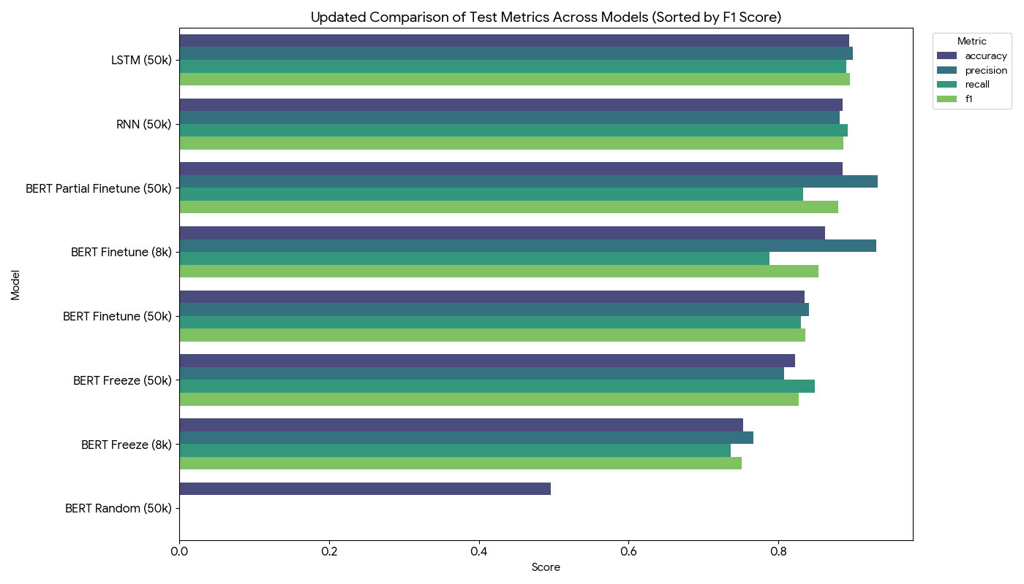
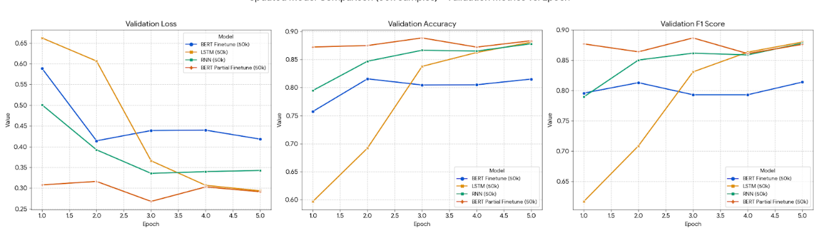
Observations:
- The LSTM and RNN models, leveraging a stable architecture and GloVe pre-training, achieved the highest and most balanced performance within the 5-epoch training window.
- The BERT Partial Finetune model was the only BERT variant to achieve a comparable, top-tier F1 score.
3. BERT Ablation Study: Identifying the Optimal Strategy
The ablation study on BERT variants clearly elucidates the trade-offs of different training strategies:
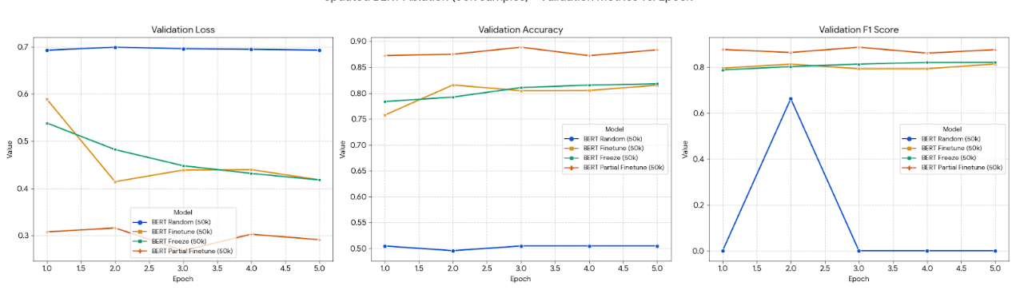
- BERT Random (F1: 0.0): Demonstrates the absolute necessity of pre-training. Without its pre-trained weights, the BERT architecture failed to learn, performing equivalently to random chance.
- BERT Freeze (50k) (F1: 0.827): Illustrates limited capacity. Training only the final classification layer was stable but insufficient for the model to adapt to the task, resulting in under-fitting.
- BERT Finetune (50k) (F1: 0.836): Highlights the difficulty of full finetuning. The model, with 110M+ parameters, was distinctly under-trained within 5 epochs. Its validation F1 was still slowly climbing, indicating it had not converged. This slow convergence explains its suboptimal test performance.
- BERT Partial Finetune (50k) (F1: 0.880): The "Goldilocks" solution. This strategy represents the optimal balance. By finetuning only the top layers, it balanced model expressivity with the number of trainable parameters, enabling it to learn effectively without the convergence issues of the full finetune approach.
4. Training Dynamics and Overfitting Analysis
Analysis of the validation F1 score over epochs reveals the distinct training profile of each model:
- LSTM / RNN: Demonstrated rapid and stable convergence. The F1 score exceeded 0.86 by epoch 3 and approached its peak near epoch 5.
- BERT Finetune (8k): Exhibited severe overfitting. The model's F1 peaked impressively at 0.895 by epoch 2 but subsequently collapsed to 0.861 by epoch 3, indicating it had begun to memorize the small training set.
- BERT Finetune (50k): Was significantly under-trained. The F1 score slowly and linearly increased, reaching only 0.814 on the validation set by epoch 5. This confirms the model required a much longer training regimen.
- BERT Partial Finetune (50k): Showed strong performance but requires early stopping. This model achieved the highest validation F1 peak of any model (0.887 at epoch 3) but then showed performance degradation in epochs 4 and 5. This highlights that Early Stopping is a critical component for optimizing this strategy.

5. Behavioral Analysis: Differentiating the Top Models
We conducted a deeper analysis of the top-tier models: LSTM, RNN, and BERT Partial Finetune.
5.1. Error Rate Analysis by Text Length (Error Buckets)
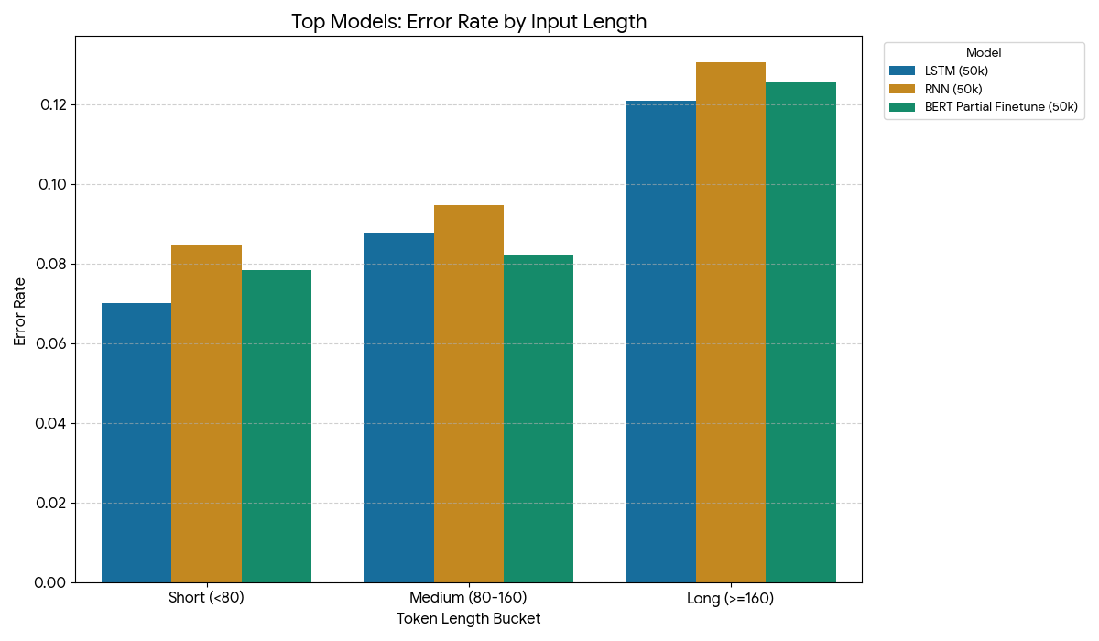
Analysis:
- All three top models demonstrate robust generalization, with error rates increasing predictably with text length.
- BERT Partial Finetune successfully overcomes the weaknesses of other BERT variants (e.g., the 16.1% error rate of Finetune 50k on short text).
- Performance is highly competitive: LSTM holds a slight advantage on short and long texts, while BERT Partial Finetune excels on medium-length texts.
5.2. Classification Behavior (Confusion Matrix)
- LSTM / RNN: These models are characterized by their exceptional balance. Their False Positive (FP) and False Negative (FN) counts were both low and nearly symmetrical (e.g., LSTM: FN=276, FP=250). They achieved an optimal trade-off between identifying positive cases and avoiding incorrect classifications.
- BERT Partial Finetune (50k): This is a "high-precision, cautious" model.
  - High Precision (0.933): It registered an extremely low FP count (151). When this model predicts "positive," it is 93.3% confident.
  - Moderate Recall (0.833): The trade-off is a higher FN count (421). It is more likely to classify ambiguous samples as "negative," thereby missing more true positive cases than the LSTM or RNN.
6. Conclusion and Recommendations
Conclusion:
- Best Overall Model: The LSTM (50k) is the best-performing and most balanced model in this experiment (F1: 0.895), achieving rapid, stable convergence.
- Best BERT Strategy: BERT Partial Finetune (50k) is the most successful BERT strategy (F1: 0.880), resolving the training difficulties of full finetuning and the performance limitations of a full freeze.
- BERT's Potential: The high F1 peaks achieved during training (0.895 for Finetune 8k, 0.887 for Partial Finetune 50k) suggest that BERT's theoretical performance ceiling is the highest, but realizing this potential is entirely contingent on mitigating overfitting and ensuring full convergence.
Recommendations:
- For Stable Deployment: Select the LSTM (50k) model. It is robust, balanced, and converges predictably within 5 epochs.
- For BERT Implementation: Employ the BERT Partial Finetune (50k) strategy. This approach must be paired with Early Stopping, monitoring the validation F1 score to capture the model at its performance peak (around epoch 3 in this case).
- Future Optimization: The BERT Finetune (50k) (full finetune) model remains a viable but challenging option. It likely requires a much longer training regimen (e.g., 10-15 epochs) and careful hyperparameter tuning (e.g., a lower learning rate) to fully converge and realize its potential.

